Getting Started with SAS

Reference: The Little SAS Book by L.D Delwiche and S.J. Slaughter

What is SAS?
Statistical Analysis System (SAS) is a statistical software package that allows the user to manipulate and analyze data in many different ways. Because of its capabilities, this software package is used in many disciplines including medical sciences, biological sciences, environmental studies and social sciences etc.

After you open SAS

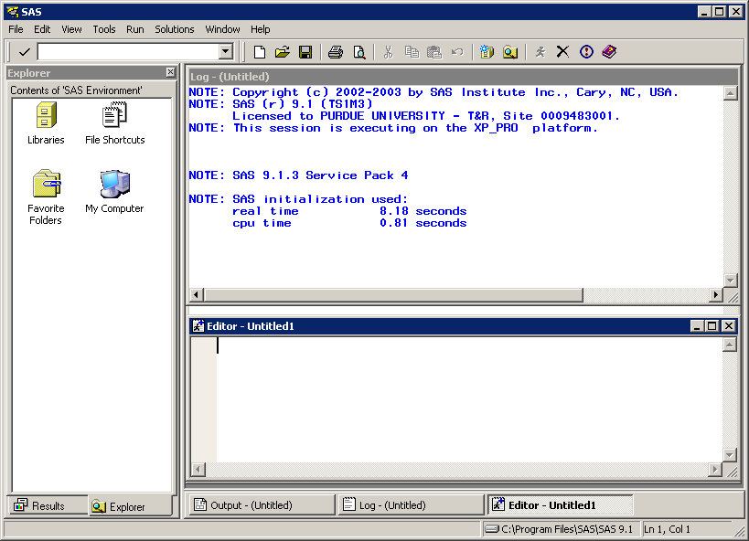

The SAS Display Manager (DM) is the standard interactive environment for the SAS system. When you start the SAS program, it displays various “windows”

- The bottom window is the PROGRAM window. You can enter a SAS program or bring in a SAS program from a file. This window has an editor that allows you to write and edit your program. When complete, you can submit your program.

- The middle window is the SAS LOG window. This window displays the program lines as the program executes, prints out messages about your data sets as they are created, and gives error messages as errors are created. Note that the error messages are shown in red color.

- The top window is the OUTPUT window. This window displays results from your SAS program. You can switch among these windows.

- RESULTS window: The Results window is like a table of contents for the Output window. The results tree lists each part of the results in an outline form.

- EXPLORER window: Gives you quick access to SAS files.

SAS is organized into two steps:

DATA step is the heart of the SAS programming. It puts data in a form that the SAS program can use. DATA step reads SAS datasets or raw data, performs transformations, creates new variables, and recodes existing variables. Data steps are important for several reasons.
- The dataset may not be in a SAS compatible format so data step is needed to transform the dataset into the appropriate format for a procedure.
- Sometimes we need to extract some of the variables or some of the observations from the dataset to perform analysis.
- Different procedures may require the same dataset in different format.

PROC step which uses procedures to do many things to the data, such as analyzing, or printing the data.

Both DATA and PROC steps consist of SAS statements.

Each SAS statement begins with a keyword that implies its function

For example, INPUT statement reads inputs;
MEANS procedure produces mean of the data;
RUN statement tells SAS to run the DATA step or PROC just completed.
A semicolon (;) is required to denote the end of each SAS statement.

SAS has many different PROCs that can be organized into functional categories:

- PROCs that manage datasets
- PROCs that analyze the contents of a data set
- PROCs that graphically display the contents of a data set. …..etc.

SAS not only provides how to create a data set within the SAS environment but also provides many different ways to create a SAS data set by importing data from many different formats such as, Excel, ASCII, Access, SPSS etc.

Reading data into SAS
There are three basic options for reading datasets into SAS.

1) With an infile statement:
Using an infile statement will bring data in from a different drive and make them available for the entire SAS session. To do this, the commands could be, for example, if the data were saved on a “C” directory then:
data example;
infile ‘C:\filename’;
input x1 x2;
run;
We must name our dataset. We can name it anything; here it is named as example. The input statement identifies the variables in the dataset so we can use them for analysis. They can also be named whatever we like; here they are named x1 and x2.
A single SAS data set can have up to 32,767 variables.

Names in SAS can contain letters, numbers, and underline characters but cannot begin with a number. Names can be in upper case, lower case, or a mixture. Names must be 32 characters or fewer in length.

2) Importing the dataset:
To import the data from another drive, go to File, and then import data. In a few seconds, a window will pop up and ask the format of the file to import. Click on the pull-down menu and select the file. Then, click next which will take you to a window that asks the file’s pathname. Type in the place where your file exists (e.g.,H:\ Homework\data). Click next again, and then it will ask you to name your data set. This can be anything you would like. Once you name it, you must continue to use this name in your program to reference this particular data set. Click next once more, and then click on the finish button.

3) Using the cards or datalines statements:
Another option is to put the dataset directly into the program editor. This generally works best when the dataset is fairly small:

data example;
input x1 x2;
cards;
your data here
;
OR
data example;
input x1 x2;
datalines;
your data here
;
It is very important that the last semi-colon go on the next line after all of the data (as shown above), otherwise the last observation will be deleted!

Important basic syntax to know:
In order to successfully run any program, we need the following basic elements:
- a semi-colon at the end of every line
- a data statement that names the data set (unless the data is imported)
- input statement (unless the data is imported)
- space between each word or statement
- a run statement

An example of this follows:
data example1;
infile ‘C:\Homework\example.dat’;
input variable1 variable2….. variablen;

If we use the cards or datalines statements instead, they must both be preceded by the input statement.

Mathematical operations are listed in the following table:
Function Operator
Addition +
Subtraction -
Multiplication *
Division /
Power ** or ^
Equal = or eq
Unequal < > or ne
Less than < or lt

To illustrate the data manipulation, let’s take a sample data set:
options nodate nonumber;
data example;
input Name $ gender $ age weight;
cards;
Jack M 13 143
Thomas M 16 132
Jessica F 19 140
Tony M 20 120
John M 15 110
Ana F 18 95
Amanda F 22 105
;

Note that $ indicates that the variable is qualitative.
Nodate nonumber option doesn’t print the date and page numbers respectively.

Suppose you want a data set of females only. The following SAS code will create a new data set called female and store those observations whose value for the variable gender is not ‘M’. The set female statement after the data example statement tells SAS to make a copy of the dataset example and save it as female. The if/then statement deletes the
observations in dataset example whose gender variable has a value ‘M’.

data female;
set example;
if gender eq 'M' then delete;
or
if gender eq 'F';
run;

If you want to include those who are 15 years or older, you can do:
data age;
set example;
if age lt 15 then delete;
run;

You can also select variables from a dataset for analysis. The statement is keep or drop. For example, if you do not need the variable age in your analysis, you can do:
data new;
set example;
drop age;
or
data new;
set example;
keep gender weight;

This last statement will create a dataset that only contains the two variables specified, gender and weight.

What is a procedure?
A SAS program is composed of one or more (statistical) procedures. Each procedure is a unit, although some are needed to run others. Some often-used procedures for statistical analysis are :

Proc print
The output of this procedure is the data set that you specified by writing
data=name option after the print key word. Here’s an example of how proc print works.

data example;
input name$ gender $ age weight;
cards;
Jack M 13 143
Thomas M 16 132
Jessica F 19 140
Tony M 20 120
John M 15 110
Ana F 18 95
Amanda F 22 105
;
proc print data=example;
run;

Note that proc print;
Run;

Also yields the same output but it is recommended to specify the name of the data so that we will know whose output is this data.
If you click on the run button, you’ll see the dataset in the output window as follows:

Obs name gender age weight
1 Jack M 13 143
2 Thomas M 16 132
3 Jessica F 19 140
4 Tony M 20 120
5 John M 15 110
6 Ana F 18 95
7 Amanda F 22 105

If you want to see only some variables in the data set, you could add a statement after the proc print line in the format of var gender age;. This would generate output similar to that shown above except the weight variable would not be included.
input gender $ age weight;
datalines;
M 13 143
M 16 132
F 19 140
M 20 120
M 15 110
F 18 95
F 22 105
;
proc print data=example;
var gender age;
run;

The output will be as below

Obs gender age
1 M 13
2 M 16
3 F 19
4 M 20
5 M 15
6 F 18
7 F 22

Proc univariate
It is one of the most important procedures for elementary statistical analysis. It yields the basic statistics of one or more variables, and has optional statements to generate qqplots and histograms.
proc univariate data=example;
var weight;
qqplot;
histogram;
run;

The var statement is optional. Without this statement, a univariate analysis is performed for all numeric variables in the order they appear in the dataset.

Proc capability
It has a variety of functions including creating a normal qq plot, histogram, and probability plots. A normal qq plot and a histogram can be created using the code in the univariate example, just replacing univariate with capability.

Proc sort
Proc sort sorts the observations in a dataset by some variables in either ascending or descending order. For
example:
proc sort data=example out=example1;
by gender;
run;

The observations of dataset example are sorted in ascending order, by default, of the variable gender, and the sorted data is saved in a dataset named example1. Without the out=example1 option, the unsorted dataset named example will be replaced by the sorted dataset. Note that by default the sorting will be in ascending order but if you want to sort in descending order you need to specify as, e.g. by gender descending.

Proc means
This procedure produces simple univariate descriptive statistics for numeric variables. It also calculates confidence limits for the mean, and identifies extreme values and quartiles:
proc means data=example alpha=0.05 clm mean median n min max;
run;

The mean, median, sample size, minimal value, maximal value, and 95% confidence intervals will be computed for variables age and weight. The alpha option specifies the confidence level for the confidence limit, clm tells SAS to calculate the confidence interval of the mean. Since gender is a categorical variable, no mean will be computed for it.

If you have a lot of variables and you only want to calculate the mean for some of them, use the var option and list the variables after the keyword var. If you want the means of the variables by group, use the by option.
For example,
proc means data=example alpha=0.05 clm mean;
var weight;
by gender;
run;
This tells SAS to compute the mean and confidence interval of weight for each value of gender, i.e. male and female. If the by statement is used, the observations need to be sorted by the same variable before the proc means procedure. Note data example1, the sorted dataset, was used in our proc means example.

Proc summary
It computes descriptive statistics on numeric variables in a SAS dataset and outputs the results to a new SAS dataset. The syntax of proc summary is the same as that of proc means. Example:
proc summary data=example1 print;
var weight;
by gender;
output out=example2;
run;

Note: Proc summary will not run without either the print option or the output statement.

Proc corr
This procedure is used for calculating the correlation between numeric variables. For example, the Pearson correlation coefficient and its P-value can be computed.

proc corr data=example;
var age weight;
run;
This will yield the following output

The SAS System

The SAS System

The CORR Procedure

2 Variables: age weight

Simple Statistics

Variable N Mean Std Dev Sum Minimum Maximum

age 7 17.57143 3.10146 123.00000 13.00000 22.00000
weight 7 120.71429 18.34588 845.00000 95.00000 143.00000

Pearson Correlation Coefficients, N = 7
Prob > |r| under H0: Rho=0

age weight

age 1.00000 -0.43017
0.3354

weight -0.43017 1.00000
0.3354

The correlation coefficient between age and weight in this example is -0.43017, and 0.3354 is the P-value for testing the null hypothesis that the coefficient is zero. In this case, the P-value is greater than 0.05, and the null hypothesis of zero coefficient cannot be rejected.

Proc glm
It performs simple and multiple regression, analysis of variance (ANOVA), analysis of covariance, multivariate analysis of variance, and repeated measures analysis of variance.
Example:
proc glm data=example;
model weight=age;
output out=example2 p=pred r=resid;
run;

It performs a simple linear regression with weight as the dependent variable and age the independent variable.
The predicted values of weight (the dependent variable) and the residuals are saved in a new dataset called example2 using the output statement.

The SAS System

The GLM Procedure

Number of Observations Read 7
Number of Observations Used 7

The SAS System
The GLM Procedure

Dependent Variable: weight

Sum of
Source DF Squares Mean Square F Value Pr > F

Model 1 373.685997 373.685997 1.14 0.3354

Error 5 1645.742574 329.148515

Corrected Total 6 2019.428571

R-Square Coeff Var Root MSE weight Mean

0.185045 15.02925 18.14245 120.7143

Source DF Type I SS Mean Square F Value Pr > F

age 1 373.6859972 373.6859972 1.14 0.3354

Source DF Type III SS Mean Square F Value Pr > F

age 1 373.6859972 373.6859972 1.14 0.3354

Standard
Parameter Estimate Error t Value Pr > |t|

Intercept 165.4257426 42.51908583 3.89 0.0115
age -2.5445545 2.38810978 -1.07 0.3354

For multiple regression where you have more than one independent variable then list all the variables on the right hand side of the equal sign with one space in between in the model statement. For example if there is another variable height then we have

model weight=age height

In the case of ANOVA, a class statement is needed for categorical variables before the model statement.
The following code is an ANOVA analyzing the effect of gender on weight. It tests whether the weight is the same for females and males.

proc glm data=example;
class gender;
model weight=gender;
run;

Proc reg
Proc reg is a procedure for regression. It is capable of more regression tasks than proc glm. It allows multiple model statements in one procedure, can do model selection, and even plots summary statistics and normal qq-plots.
You can specify several PLOT statements for each MODEL statement, and you can specify more than one plot in each PLOT statement.
proc reg data=example;
model weight=age;
plot weight*age;
plot predicted.*age;
plot residual.*age;
plot nqq.*residual.;
run;

In the above example, a simple regression is performed with weight as the response and age as the explanatory variable. The plot statements request four plots: weight versus age, predicted values of weight versus age, residuals versus age, and normal qq plot versus residuals. Predicted., residual., and nqq. are keywords that SAS recognizes.

Note the dot after residual, predicted and nqq.

Basic Options and Statements within the Procedures
What is an option or statement?
A statement is a command nested within the procedure commands that tell SAS a bit more about the procedure you want to perform or in some cases, allows you to make your analysis more specific. An option is something that even further describes a statement, or in some cases, it may also further describe a procedure. Some statements are necessary while others are optional

The Var Statement
In many of the above SAS procedures, a var statement is either required or may be needed if you are dealing with a large data set with many variables.
For example, if you are using the proc corr procedure you may want to tell SAS which variables in your dataset you are interested in obtaining correlations for. It would work as follows if you had three variables for which you needed to obtain the correlations:
proc corr data=example
var Variable1 Variable2 Variable3;
run;

If you have a dataset with many variables, but you only want to check normality assumptions for a few of them, use:
proc univariate data=example;
var response1 response2;
run;
The By Statement
The by statement is required for the proc sort procedure. After using it in proc sort, you can then use it in other procedures. For example, say you were interested in performing regressions of height on weight by gender. First, you would want to sort your dataset by gender as follows:
proc sort data=example;
by gender;
run;

Then, you can use the sorted data to obtain two separate regressions, one for males and one for females as follows:
proc reg data=data;
model weight=height;
by gender;
run;

The Class Statement
The class statement tells SAS that you have a variable in your data set that is categorical. For example, if you had data from an experiment with 15 subjects where five subjects received treatment 1, five received treatment 2 an the rest five received treatment 3 then treatment would be considered a categorical variable, and thus must appear in the class statement of the glm procedure. The most common usage of the class statement will be in the univariate, means, and glm procedures. It is required for the glm procedure only if you have a categorical variable such as gender. For example
proc glm data=data;
class treatment;
model resp=treatment;
run;
where resp is the response for each of the 15 subjects.

The Model Statement
The model statement tells SAS which model you would like to use for your data. The dependent or response variable always goes on the left of the equals sign while the independent variable(s) come after the equals sign on the right.
The above glm example shows how the model statement works. In proc reg, the model statement has options for these same things, plus many other options such
as standard errors for the regression coefficients, step-wise regression and specialized regression diagnostics. An example of how to use options in the model statement is as follows:
proc reg data=xyz;
model weight=height / stb;
run;

Note the forward slash for options coming after the model statement. We can use as many options as we need in one model statement, but just make sure that all of them are separated by one space.
The option stb asks for the standardized regression coefficients.

The Means and Lsmeans Statements
Often in an analysis, once differences are found among groups, we would like to see exactly where those differences occur; this is done in SAS by the use of the means and lsmeans statements in proc glm or proc reg. Both the means and lsmeans statements can be used in conjunction with a variety of options. If there is no missing values in the data set, which is called a balanced design, and if we have no covariates, we can use the means statement. However, if missing values exist or it is an unbalanced design, or we have covariates on the model, we must use lsmeans to obtain the proper means and comparisons. Example:
proc glm data=example;
class treatment;
model resp=treatment;
means treatment / lines tukey bon;
run;

The means statement will perform means comparisons for all four treatment groups in this case. The options lines, Tukey, and Bon are used. The lines option displays the means comparisons in a more readable format. The Tukey and Bonferroni options correspond to two types of means comparisons procedures. Many other options for different means comparison procedures also exist (i.e. Dunnett, least squared differences, Duncan, Scheffe, Student-Newman-Kuels).

When using the lsmeans statement, the syntax is
lsmeans treatment / adj=tukey stderr;

When using lsmeans, we must use the “adj=” option to obtain Tukey and Bonferroni comparisons, for example. The stderr option gives the standard errors for the least squares (ls) means.

Options in the Procedures

Some options contained in the procedures come not in the model or the means statements, but directly after the proc statement. For example:
proc glm data=xyz alpha=.05;
class treatment;
model resp=treatment;
means treatment / lines tukey bon;
run;

In this example, it becomes apparent that the “data=xyz” option is really an option as there is only one data in the procedures statement. The alpha=.05 option tells SAS that for any confidence intervals, significance testing, etc. we want an alpha of .05. We can change the value of alpha in desired level.

Another useful example of options in the proc statement is with proc univariate. By using options in the procedures statement, you can obtain stem-and-leaf plots, normal probability plots, boxplots, and tests for normality.

proc univariate data=xyz normal plot;
var response1 response2;
run;

The normal option gives the Shapiro-Wilks test of normality, while the plot option produces the stem-and leaf plot, boxplot, and normal probability plot.

Output Statements (used in many procedures)
The basic function of the output statement is to create a new dataset containing both the information in the old dataset plus any new diagnostics or statistics that the procedure has created. For example, if you specify a dataset for your reg procedure, you may want to output that dataset along with predicted values and residual values.
Options for obtaining predicted values, residual values, and other statistics and diagnostics for example:

proc reg data=one;
model response=var1 var2;
output out=two r=res p=pred;
run;

So, now you have a data set named “two” which contains everything that dataset one contains, plus the residual and predicted values from your proc reg model. Now, you can make diagnostic plots as follows:

proc gplot data=two;
plot res*pred;
plot res*var1;
plot res*var2;
run;

These plots can help to assess normality, independence of observations, and constancy of variance. There are many other options besides residual and predicted values depending on which procedure you are using for your analysis
Another example of an output statement used with the proc univariate statement:

proc univariate normal plot data=data1;
var x;
output out=data2 max=maximum min=minimum mean=mean;
run;

This will give the mean, maximum, and minimum values for x in the data set “data2”.

Working with Graphics in SAS
The two basic graphic procedures in SAS are proc plot and proc gplot. These two procedures are fairly similar; however, proc gplot will usually allow us to produce better looking and more sophisticated graphs than proc plot.

Proc Plot
In proc plot, there are a few nice tricks to know. For example, if you are checking constancy of variance assumption and want to plot the residual variable against more than one independent variable (on separate graphs) you can use:

proc plot data=diag;
plot res*(x1 x2 x3);
run;

Note that the diag dataset must have been created from a previously run proc reg statement, and thus would contain, in addition to the original dataset the residual values, predicted values, etc. This way, we don’t have to write more than one plot statement.

Another option (using the previous example) to have all three plots on the same graph is to use overlay:
proc plot data=diag;
plot res*(x1 x2 x3) / overlay;
run;

Proc plot contains some options both on the proc statement itself and the plot statement for adjusting the axes, labeling points, and controlling the size of the plot. Use help menu for detail.

Proc gplot
Proc gplot has more options and can produce better graph than proc plot. The basics to know about gplot are how to choose symbols and how to draw regression lines.
Example

symbol value=circle i=r ci=red cv=blue;
proc gplot data=new;
plot y*x;
run;

The symbol value statement has many other options other than circle . The i=r statement draws the linear regression line and gives the linear regression equation .
Note that the equation will appear in the LOG window not in the output window.
The ci=red option makes the regression line red and the cv=blue makes the plotted points show up as blue. The remaining statements are similar to proc plot. gplot also has the capability to overlay plots and many other options for adjusting axes values, changing colors, changing the legend, etc.

Working with DATEs in SAS

- When once SAS knows it is reading a date, it converts the date into the number of days from January 1, 1960. Dates after January 1, 1960 are stored as positive numbers, and the dates before January 1, 1960 are stored as negative numbers.

- For example, 01/01/1959 is stored as -365
01/01/2001 is stored as 14976

SAS uses INFORMATS for reading dates, FUNCTIONS for manipulating dates, and FORMATS for printing dates.

We can use a date as a constant in a SAS expression by adding QUOTES and a letter D.
For example, earthday = ‘22apr2005’D;

- Following are various informats that can be used to read the date values:

SAS informat Example of input data

mmddyy6. 112195
ddmmyy6. 211195
yymmdd6. 951121

mmddyy8. 11211995
mmddyy8. 11/21/95
ddmmyy8. 21111995
yymmdd8. 19951121

mmddyy10. 11/21/1995
date7. 21NOV95
date9. 21NOV1995
monyy5. NOV21
monyy7. NOV1995

julianw. reads dates in form: yyddd or yyyyddd (eg. 65025 or 1965025)

IV. Miscellaneous SAS Issues

Note that you do not have to run the entire program every time you make a correction to your SAS program. Each SAS procedure is relatively independent of other procedures. As long as you have the dataset you need in this procedure in SAS, you can run only part of the program by highlighting the part of the program you want to run and then clicking the run button in the tool bars.

- Missing values. Dots for missing observations. If the data set has missing values, you’ll need to specify them as a dot in the SAS dataset.

- What if data set does not have dots? You can add a dot to the corresponding missing value locations using a data step. For example, if you have two variables, X and Y, in your data set, and 10 observations. The ninth value of Y is missing. The following code with an if statement will do:

data a2; set a1;
If _n_ eq 9 then Y=.

- Reading in data @@.

We have seen that when we input our dataset after a CARDS or DATALINES statement, every observation needs to be on an individual line. In case we want to make better use of the window and want to have more than one observation per line, @@ is the syntax that tells SAS where the end of one observation is.
For example:
data dataset;
input x y z @@;
cards;
1 2 3 4 5 6 7 8 9
;

- What if my Excel data file is not reading properly into SAS or not at all?
If the Excel data file is not reading into SAS at all, most likely it’s because your Excel data file is open. The Excel file must be closed before you import it into SAS. There are other reasons that the Excel data file is not reading in properly. It could be that the data type of your Excel cells is not correctly defined. Inappropriate reading also happens when you do not have a header in the first row, since the import procedure takes the first row as header by default. However, this can be changed during the import procedure under options.

How do you know if SAS is reading your dataset correctly? Use the proc print procedure and see if the dataset in SAS is what you expected.

How to use the help menu
The SAS help menu is helpful if you want to self-improve your knowledge of SAS procedures. There are two ways of getting SAS help.

One is to go to the help menu and then SAS system help. Then go to the Index tab and type in the name of the procedure. SAS will give you the syntax of the procedure as well as some examples..

Example: Consider a data containing 26 automobiles with their make, mpg, repair record, weight, and whether the car was foreign or domestic. The program below reads the data and creates a temporary data file called auto. The graphs shown in this module are all performed on this data file called auto.
DATA auto;
INPUT make$ mpg rep weight foreign ;
CARDS;
AMC 22 3 2930 0
AMC 17 3 3350 0
AMC 22 . 2640 0
Audi 17 5 2830 1
Audi 23 3 2070 1
BMW 25 4 2650 1
Buick 20 3 3250 0
Buick 15 4 4080 0
Buick 18 3 3670 0
Buick 26 . 2230 0
Buick 20 3 3280 0
Buick 16 3 3880 0
Buick 19 3 3400 0
Cad. 14 3 4330 0
Cad. 14 2 3900 0
Cad. 21 3 4290 0
Chev. 29 3 2110 0
Chev. 16 4 3690 0
Chev. 22 3 3180 0
Chev. 22 2 3220 0
Chev. 24 2 2750 0
Chev. 19 3 3430 0
Datsun 23 4 2370 1
Datsun 35 5 2020 1
Datsun 24 4 2280 1
Datsun 21 4 2750 1
;
proc print;
run;
TITLE 'Simple Vertical Bar Chart';
PROC GCHART DATA=auto;
VBAR mpg;
RUN;

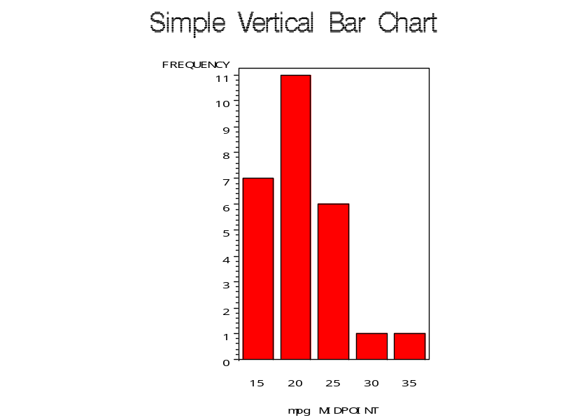
We can control the number of bars as
PROC GCHART DATA=auto;
VBAR mpg/levels=10;
run;

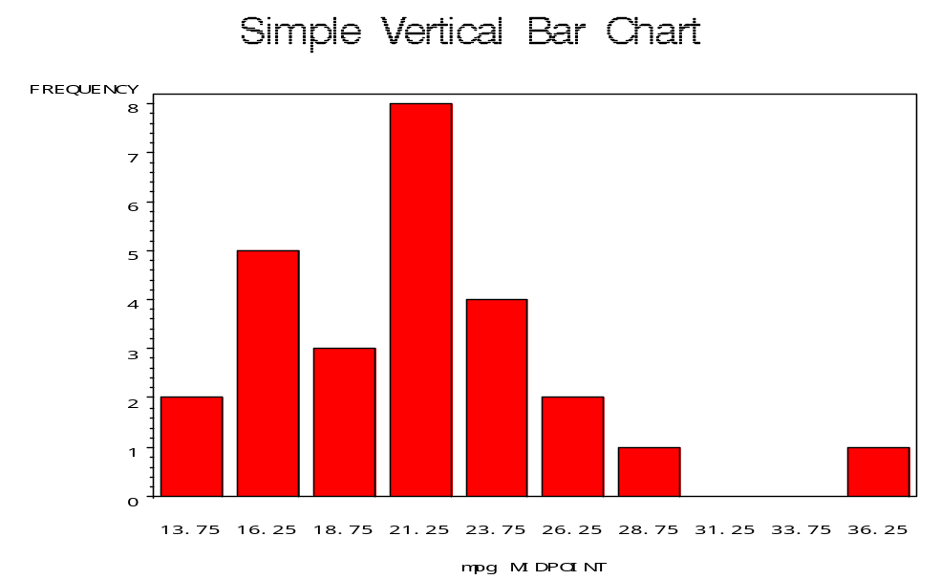

Also we can produce horizontal bar graphs as

TITLE 'Horizontal Bar Chart with Discrete';
PROC GCHART DATA=auto;
HBAR rep/ DISCRETE;
RUN;
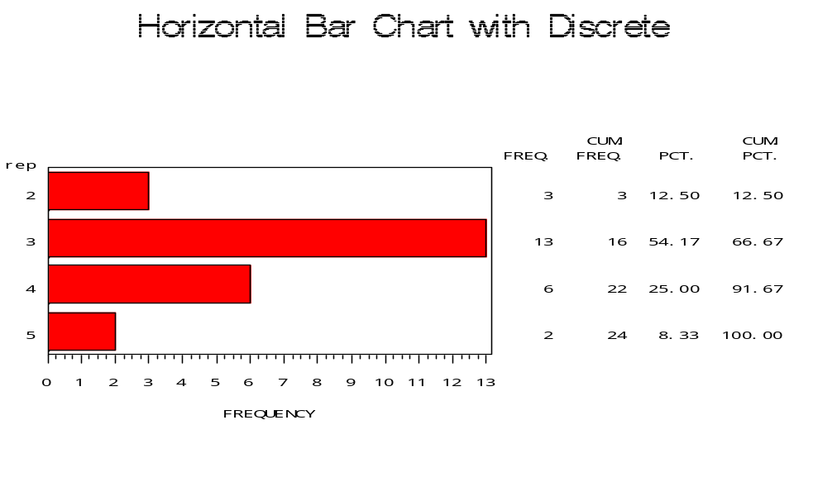
Pie Chart can be drawn for the given data as below

TITLE 'Pie Chart of Repair Record ';
PROC GCHART DATA=auto;
PIE rep/ DISCRETE VALUE=INSIDE
PERCENT=INSIDE SLICE=OUTSIDE;
RUN;

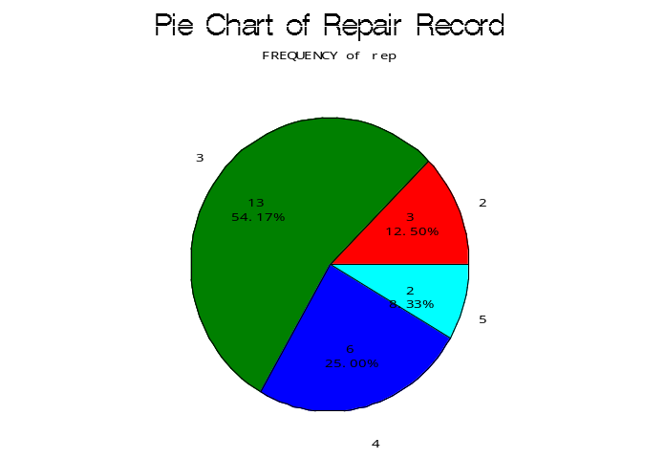
Also we can have 3 dimensional pie chat
TITLE 'Pie Chart of Repair Record ';
PROC GCHART DATA=auto;
PIE3D rep;
RUN;

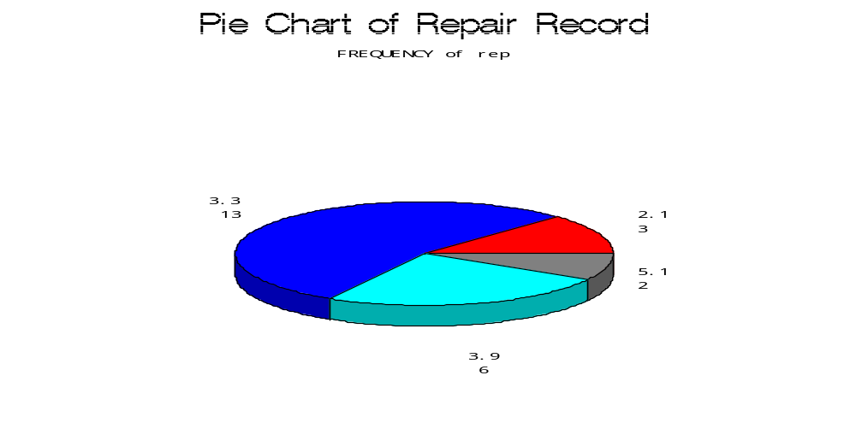

To produce steam and Leaf plot, Box plot, Normal probability plot

TITLE 'Stem and Leaf Plot and Box-Plot';
PROC Univariate DATA=auto plot;
VAR mpg;
RUN;

The UNIVARIATE Procedure
Variable: mpg

Extreme Observations

----Lowest---- ----Highest---

Value Obs Value Obs

14 15 24 25
14 14 25 6
15 8 26 10
16 18 29 17
16 12 35 24

Stem Leaf # Boxplot
34 0 1 0
32
30
28 0 1 |
26 0 1 |
24 000 3 |
22 000000 6 +-----+
20 0000 4 *--+--*
18 000 3 | |
16 0000 4 +-----+
14 000 3 |
----+----+----+----+

Normal Probability Plot
35+ *
| ++
| ++++
| *++++
| ++*+
25+ +**+*
| ****+*
| ***++
| *+*++
| *+**+
15+ * *+*++
+----+----+----+----+----+----+----+----+----+----+
-2 -1 0 +1 +2

More about GPLOT
The GPLOT procedure provides the ability to draw a line through the data, either interpolating the data (going through each point) or approximating the data with a single polynomial regression curve of degree one, two, or three.
The interpolation methods include piecewise linear, a step function, and cubic spline interpolation. Interpolation methods provide a fit between two points in the order that these points occur in the dataset, so ordinarily, when interpolation is used, the data are sorted by the values on the horizontal axis.
The type of line to fit to the data is specified with the INTERPOL keyword, which can be used in the GOPTIONS statement. The INTERPOL keyword is used both for interpolation and for regression fitting.
Straight lines joining successive points can be specified by Interpol= join
A cubic spline joining successive points can be specified by Interpol= spline
If the data are not sorted, the cubic spline joining successive points along the horizontal axis can be specified by Interpol= splines
A simple linear regression can be specified by Interpol= r
A second-degree (quadratic) regression can be specified by Interpol= rq
A third-degree (cubic) regression can be specified by Interpol=rc
A simple linear regression with 95% confidence bands for the mean can be specified by Interpol= rlclm95
If a line is fit to the data, the points themselves are generally not plotted unless it is explicitly requested to be done. This is done by use of the SYMBOL keyword, which can be specified in GOPTIONS or in a separate SYMBOL statement. The symbol to use in plotting data points is specified in the VALUE keyword. The INTERPOL keyword can also be used in the SYMBOL statement, so that is usually the simplest way.
A simple linear regression line with 95% confidence bands for the data above can be requested as follows.
TITLE '95 % confidence Interval';
Symbol value= diamond Interpol=rlclm95;
Proc gplot data=auto;
Plot mpg*weight;
Run;

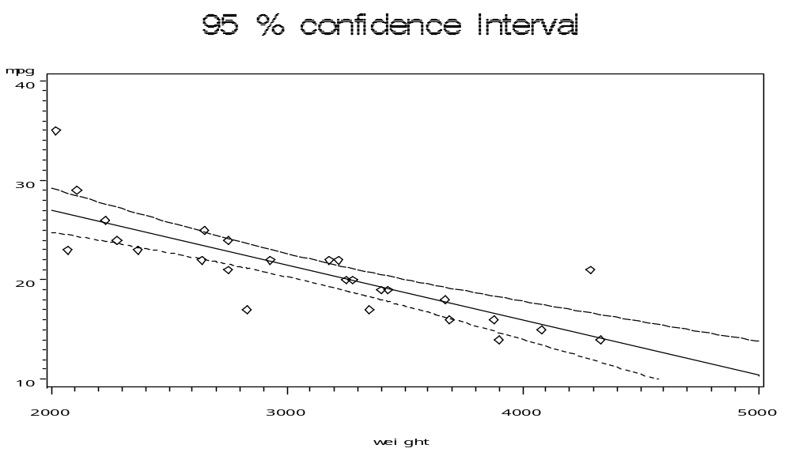

Remark: One can use ods option to get the output either in pdf or .rtf format

ods pdf body="c:\test.pdf" ;
data stock;
input y x1 x2 @@;
datalines;

……..
run;
ods pdf close ; ods listing ;

It will produce the .pdf format output in c drive.

Note that SAS for windows has a built-in menu driven way of producing these plots (as well as obtaining basic statistical output) without having to write any programs. For example to obtain the histogram in SAS,
On the top toolbar, click with your mouse on “Solutions" followed by “Analysis" followed by “Analyst":

Solutions Analysis Analyst:

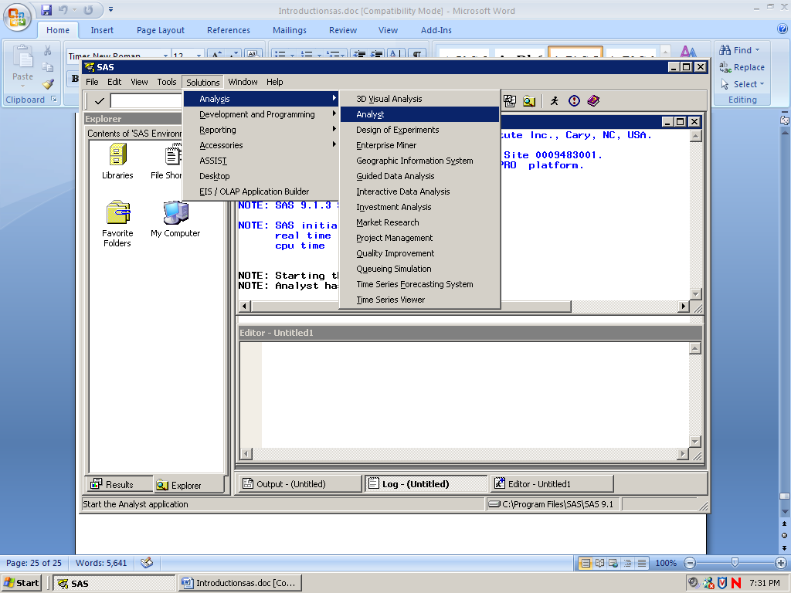

A new window will pop up.

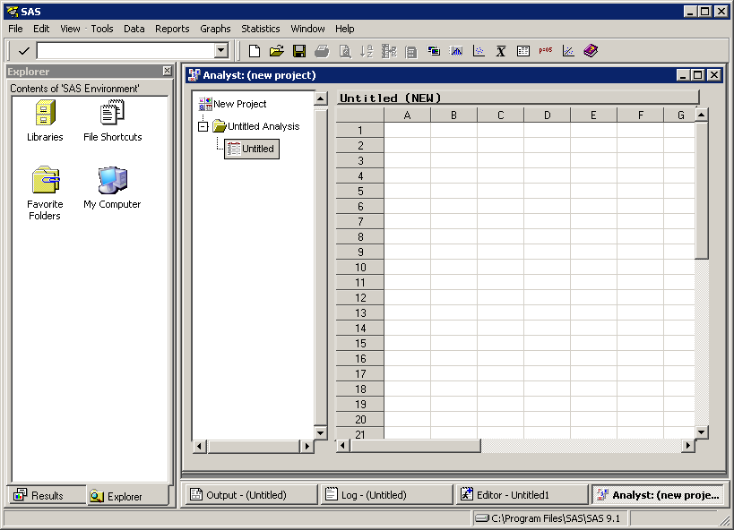

Now, one can use this as an excel sheet and perform many statistical analysis.
For example,

Under the file menu, choose “Open by SAS name". Double-click on the “Work" file which contains all the SAS data sets in operation. Next, double-click on “Data name". You will See the data set open up in the Analyst window. At the top along the toolbar you will see several options. Choose “Graphs" and click on “histogram". Click on the variable of interest followed by “Analysis" followed by “OK". This will produce the histogram.

You can find several other commands in this window.

